**I. Product Information**

|  |  |
| --- | --- |
| Packaging Material Name | Café Gusto White Coffee Mix  -Roll Form |
| Item Code | LBL-CGWC |

**II. Specifications**

1) Material Properties

|  |  |  |
| --- | --- | --- |
| **MATERIALS COMPOSITION** | **THICKNESS (MICRONS)** | **GRAMMAGE (GSM)** |
| PET | 12.00 µ | 16.80 |
| Ink | 2.00 µ | 2.0 |
| Adhesive | 3.00 µ | 3.00 |
| Aluminum | 7.00 µ | 18.90 |
| Adhesive | 3.00 µ | 3.00 |
| PE | 60.00 µ | 55.50 |
| **Total** | **87.00 µ ± 10 %** | **99.20 µ ± 10 %** |

2) Packaging Constructions

|  |  |
| --- | --- |
| Style | Printed Dry Lamination/Roll Form |
| Barcode Number | **4806538450005** |
| Basis Weight | 99.20 gsm ± 10 % |
| Total Thickness | 87.00 µ ± 10 % |
| Roll Dimension | Roll Length:1000 m ± 2 mm  Roll Width:200 mm ± 2 mm  Repeat Length:108 mm ± 2 mm |
|  | Roll Width: 134mm ± 2 mm |
|  | Repeat Length: 150mm ± 2 mm |
| Bond Strength | PET/Alum: 150g/15 mm (min.) |
|  | PET-Al/PE:300g/15 mm (min.) |
| Solvent Retention Result | 5.0 mg/m2 max.) |

3) Physical Attributes

|  |  |
| --- | --- |
| Color Print | Must be consistent with the approved LSD |
| Finished Product | No rough surfaces, no scratches |
| Printing | No misregistration, misprint and misspelling |
| Barcode | Must be easily read by the scanner |

**III. Storage Condition**

Laminated Foils should be stored in clean and dry area at ambient temperature (27-400C),

away from strong odors, heat, and direct sun light.

**IV. Illustration**

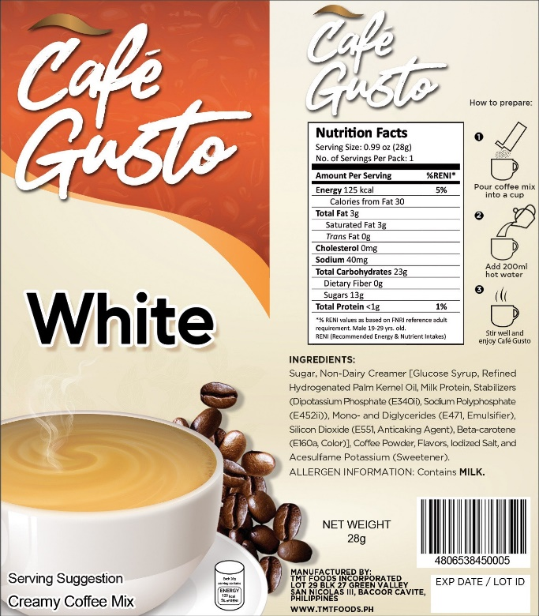

Café Gusto – White Flat Layout

Café Gusto – White Roll Form

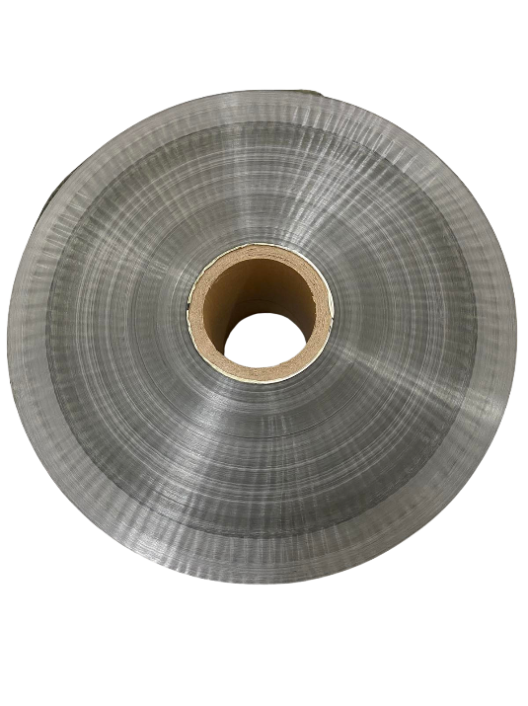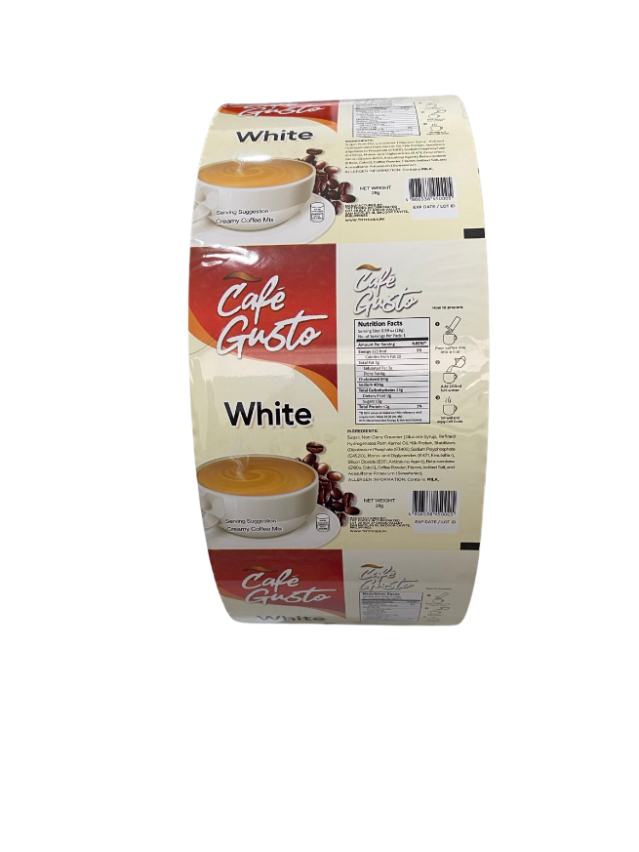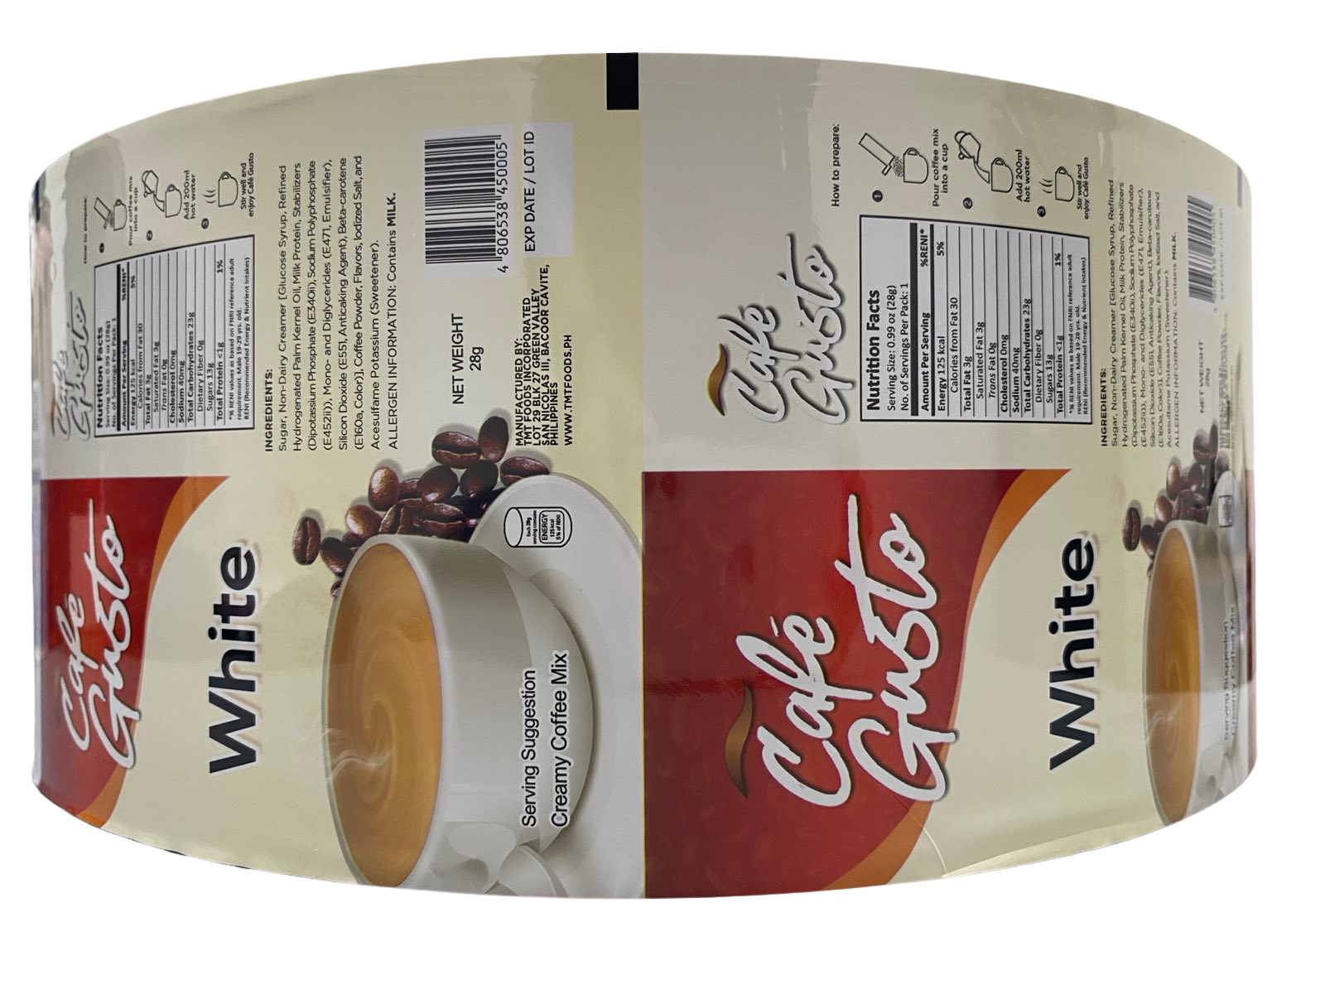

**Revision Record**

|  |  |  |  |
| --- | --- | --- | --- |
| Revision no. | Date | Revision | Author |
| 00 | January 29, 2024 | Initial Issue | C. Quintans |